**Lab 6: NPN Cascode Amplifier**

EE 3310L

Spring 2023

Alex Yeoh

Cauy Gibson

Submitted to TA: C. Hicks Friday 8:00 AM

Date of Experiment: 02/17/23

Date of Submission 02/24/23

1. **Introduction**

The purpose of this lab is to construct and test an NPN cascode amplifier using 2N3904 transistors [1]. A cascode amplifier is a common-emitter amplifier directly coupled to a common-base amplifier. The DC values of the circuit can be measured separately from any portion with a capacitor between them the transistor due to capacitors acting like open circuits with DC.

1. **Experimental Methodology [1]**

The first step of the experiment is constructing the circuit following figure 1 below, while ensuring that none of the transistors have an hFE less than 100.

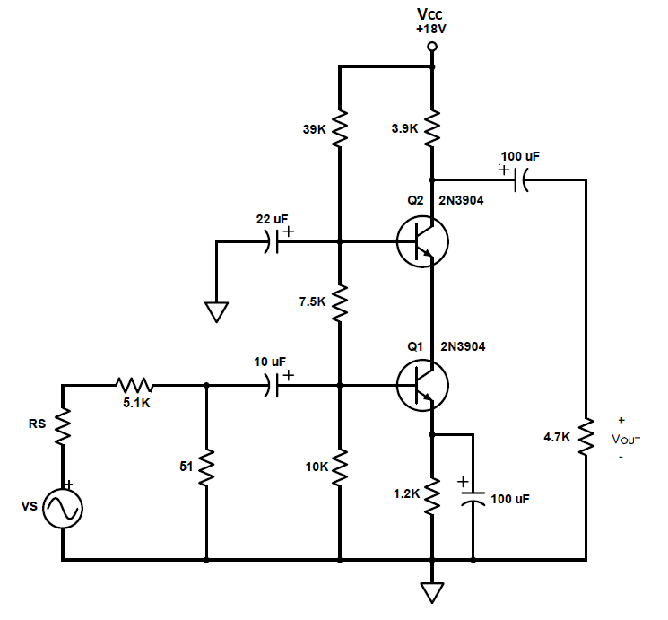

Figure 1: DC portion of a common-emitter NPN voltage amplifier

From the circuit, VB, VE and VC are measured for both transistors. The VE of the transistor Q1 should have a value of approximately 2.5V.

The signal generator is then set to a 1Vp-p and 1kHZ sine wave. The peak-to-peak output voltage is then measured. The frequency is then increased until the output has decreased by 3dB, the resulting frequency is written down as the upper cutoff frequency. The frequency is then decreased until the output has also decreased by 3dB, the resulting frequency is written down as the lower cutoff frequency. The signal generator is then brought back to a frequency of 1kHz, and the peak-to-peak voltage is then increased until the output waveform is visibly clipping.

1. **Results and Description**

The measured values of VB, VE and VC for Q1 in the circuit in figure 1 above, when the signal generator is off, are 3.01V, 2.34V and 4.66V respectively. And the measured values of VB, VE and VC for Q2 in the circuit in figure 1 above, when the signal generator is off, are 5.29V, 4.66V and 10.63V respectively.

The wave generated from the circuit in figure 1 above did appear to look like an inverted sine wave.

The circuit in figure 1 above had a measured peak-to-peak output voltage of 1.54VP-P. From this value, the calculated gain from the circuit seen in figure 1 can be seen in equation 1 below.

$A_{V}=\frac{V_{OUT}}{V_{S}}=\frac{1.96}{(1/100)}=154=43.75dB$ (1)

The measured upper and lower cutoff frequencies for the circuit seen in figure 1 above are 3.90MHz and 89Hz respectively.

The peak-to-peak voltage at which the circuit seen in figure 2 above’s waveform appears clipped is 3.40Vp-p.

1. **Discussion**

The analytically determined DC operating point can be seen below in figure A1 in appendix a. The analytically determined gain, and both upper and lower cutoff frequencies can be seen below in figure A2 in appendix a.

The Multisim simulated DC operating point for a common-emitter amplifier can be seen below in figure 2.

Figure 2: Simulated DC operating point from Multisim for a cascode amplifier

The Multisim simulated gain and both upper and lower cutoff frequencies for a common-emitter amplifier can be seen below in figure 3.

Figure 3: Simulated gain from Multisim for a cascode amplifier with upper and lower cutoff frequencies displayed

The calculated, simulated, and experimental DC operating points were similar. In absolute terms, all three gains were similar; however, the simulated gain seems to imply that the gain is not inverted while calculated and experimental values say that gain is inverted. The calculated and simulated lower cutoff frequency were relatively similar, but the experimental lower cutoff frequency was lower. The upper cutoff frequencies were relatively spread apart, the calculated value being approximately in the middle of both the experimental and simulated values.

1. **Summary and Conclusions**

The most of lab itself is simple and straightforward to complete due to the instructions given.

**Reference**

[1] Tritschler, Joe. "NPN Cascode Amplifier." N.p., n.d. Web. 17 Feb 2023.

**Appendix A**

Analytical Calculations for Lab 6

Figure A1: DC analysis for an NPN cascode amplifier.

Figure A2: Frequency analysis for an NPN cascode amplifier